fUNCTIONAL sPECIFICATION dOCUMENT

School Management System Ver. 0

Table of Contents

Setup Forms 3

1. Class Setup 3

2. Section Setup 3

3. Student Setup 3

Quarter Setup 4

Bank Setup 5

School Setup 6

Transaction Form 6

Fee Process 6

Fee Collection 7

Student Promotion Form 8

Reports 10

Class LIST 10

Section List 10

Student Lis 10

Student List criteria form 11

Quarter List 12

Fees Slip Print 12

Fees Slip format 13

Arrear LIST 13

Criteria Form 13

Report Format 15

Fee Register 15

# Setup Forms

## Class Setup

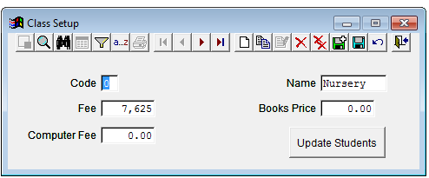

Separate define fee heads and then assign to class.

## Section Setup

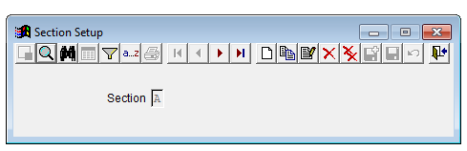

Section Code and Section Name

## Student Setup

Status of student (Left, Stuck off)

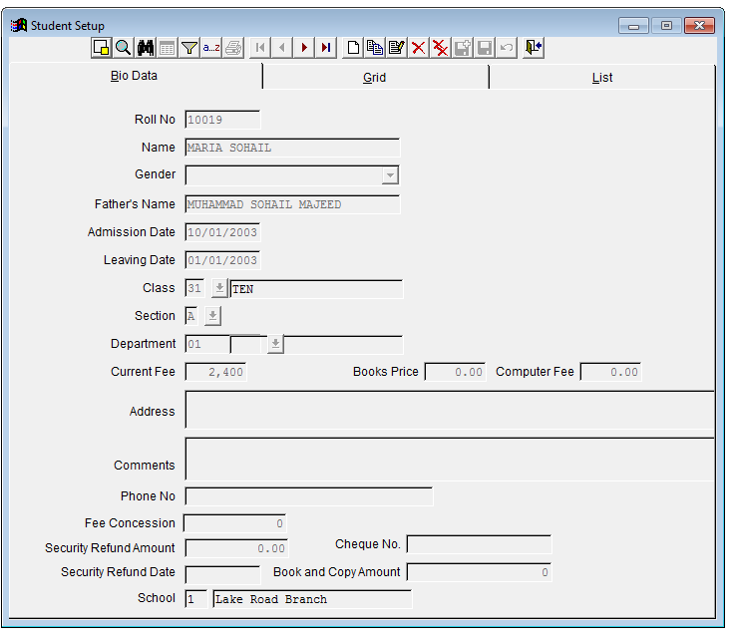

Fee structure in list with student

Comments save in fee collection when run fee process.

Student status active/left/stuck off

Create fees vouchers

Print cash slip and create integration with GL

## Quarter Setup

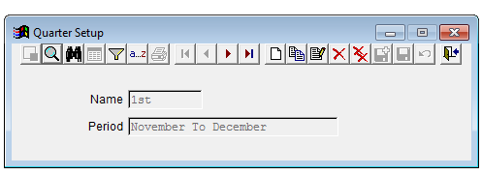

## Bank Setup

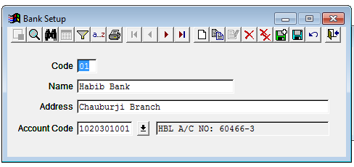

Fee Default

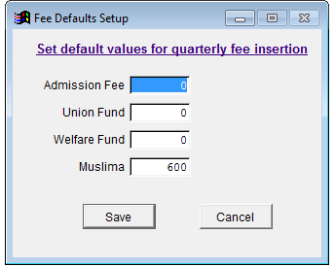

Here user will create fee structure list. This lit then import in class setup and then update in student bio data.

## School Setup

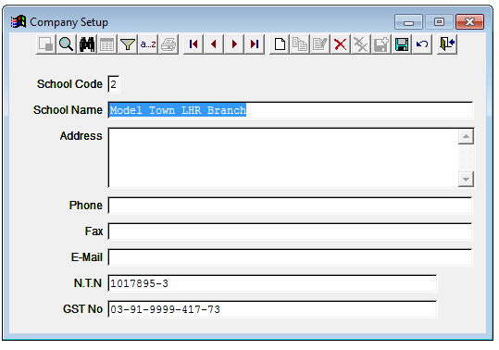

# Transaction Form

## Fee Process

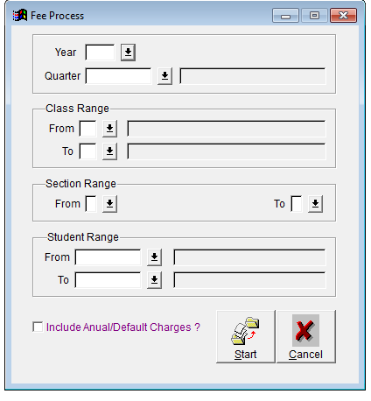

Same design but have the option to just enter quarter and create fees voucher of all classes and all sections with arrears.

When create fees and an option in system to update these fees slip data in UBL system.

When bank collect fees again an option will click to get collection data and update in school management System.

## Fee Collection

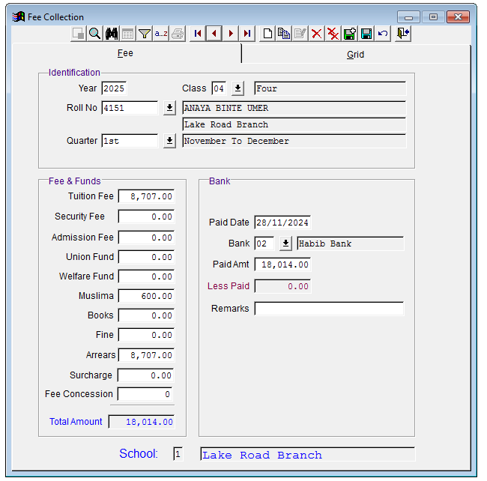

This will update when bank collet fees.

## Student Promotion Form

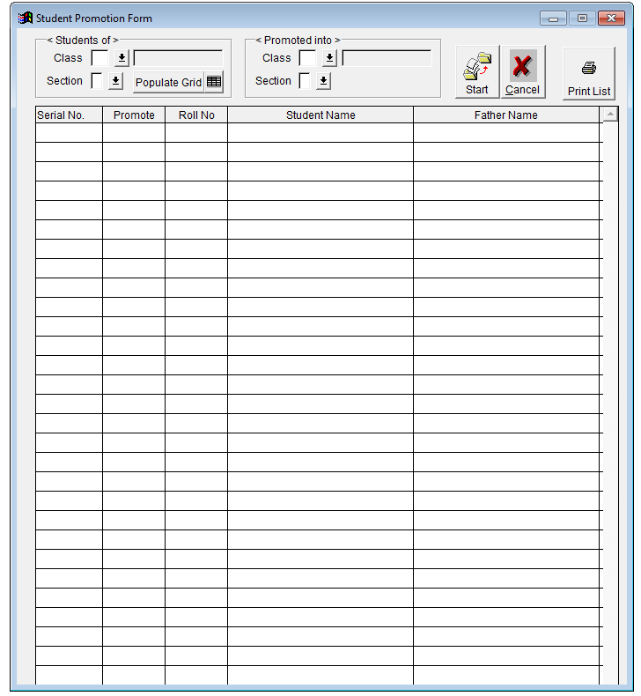

By default all tick.

# Reports

## Class LIST

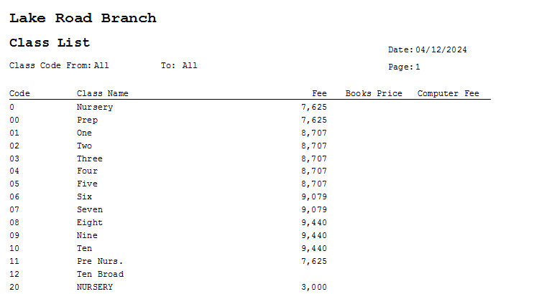

## Section List

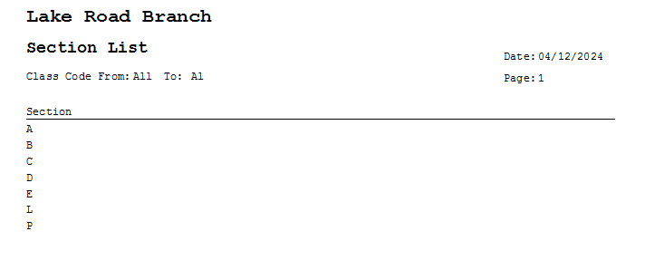

## Student Lis

## Student List criteria form

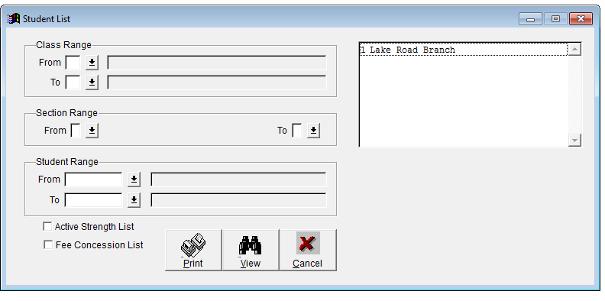

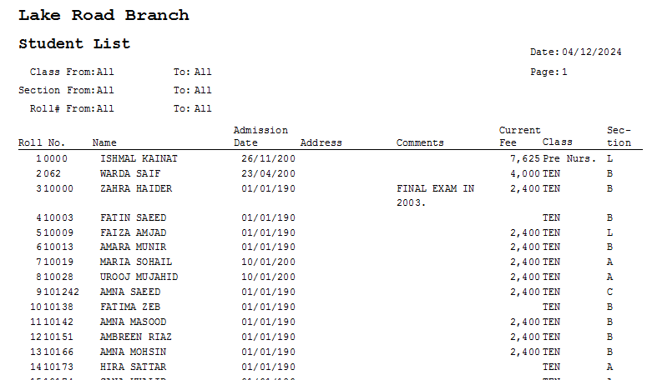

## Quarter List

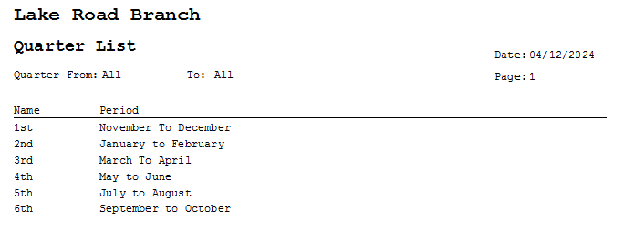

## Fees Slip Print

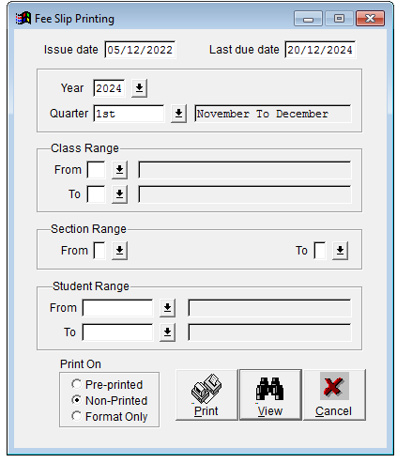

## Fees Slip format

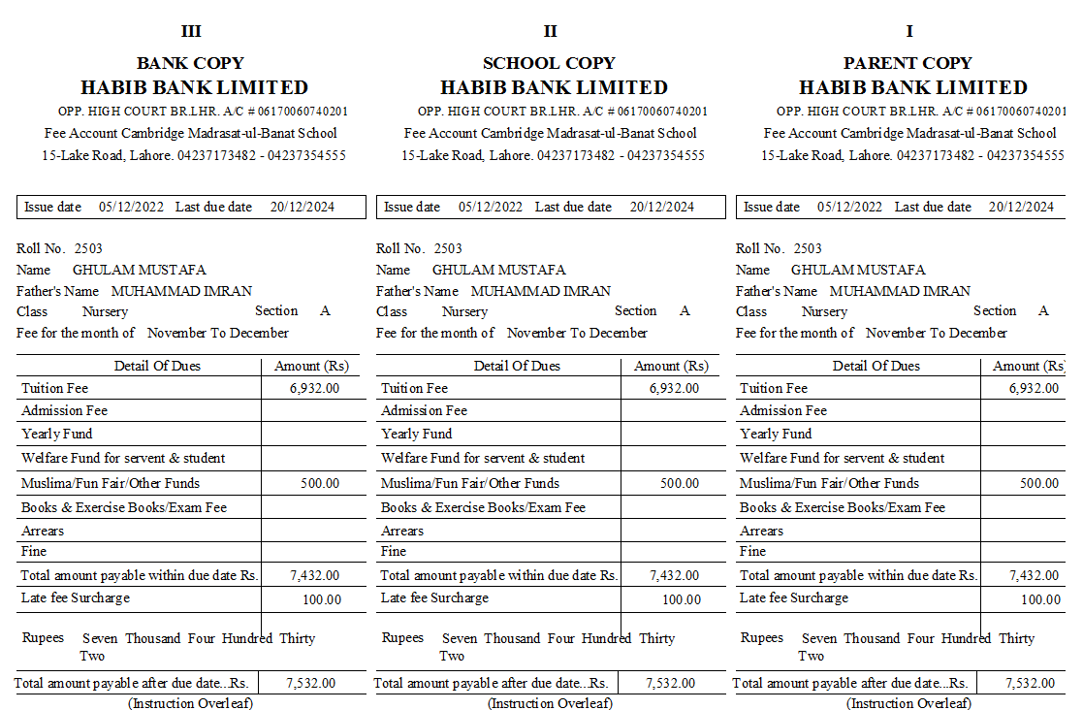

## Arrear LIST

## Criteria Form

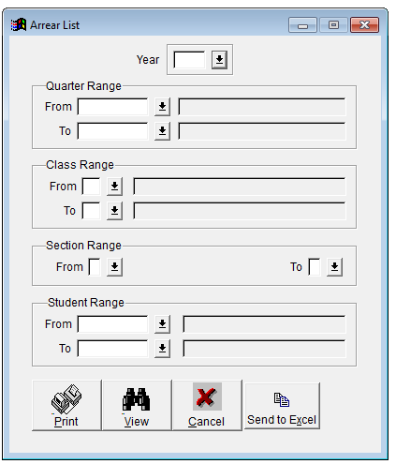

## Report Format

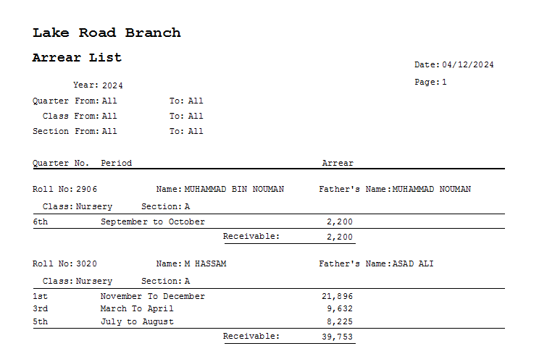

## Fee Register

